These worksheets accompany Scenario Planning for Climate Change online education.  The book is available online from Amazon. | 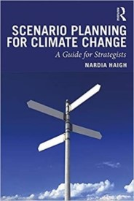

Focal Question and Time Horizon
Your question:
How could my career/retirement look 15 years from now, and how should I prepare?

Identifying Key Stakeholders
Identify 3-4 (or more) key stakeholders that are important to your career/retirement

Identify, Rate and Rank Drivers
Scenario Planning: Rating and Ranking the Driving Forces
Driving Forces (identify and consider at least 4) | A. Uncertainty (out of 10):  1 (certain) --> 10 (uncertain) | B. Impact if it happens (out of 10): 1 (no impact) --> 10 (significant impact) | (AxB)
1. In 15 years,
2. In 15 years,
3. In 15 years,
4. In 15 years,
5. In 15 years,

Develop Scenarios
Write very brief scenarios in the spaces below.
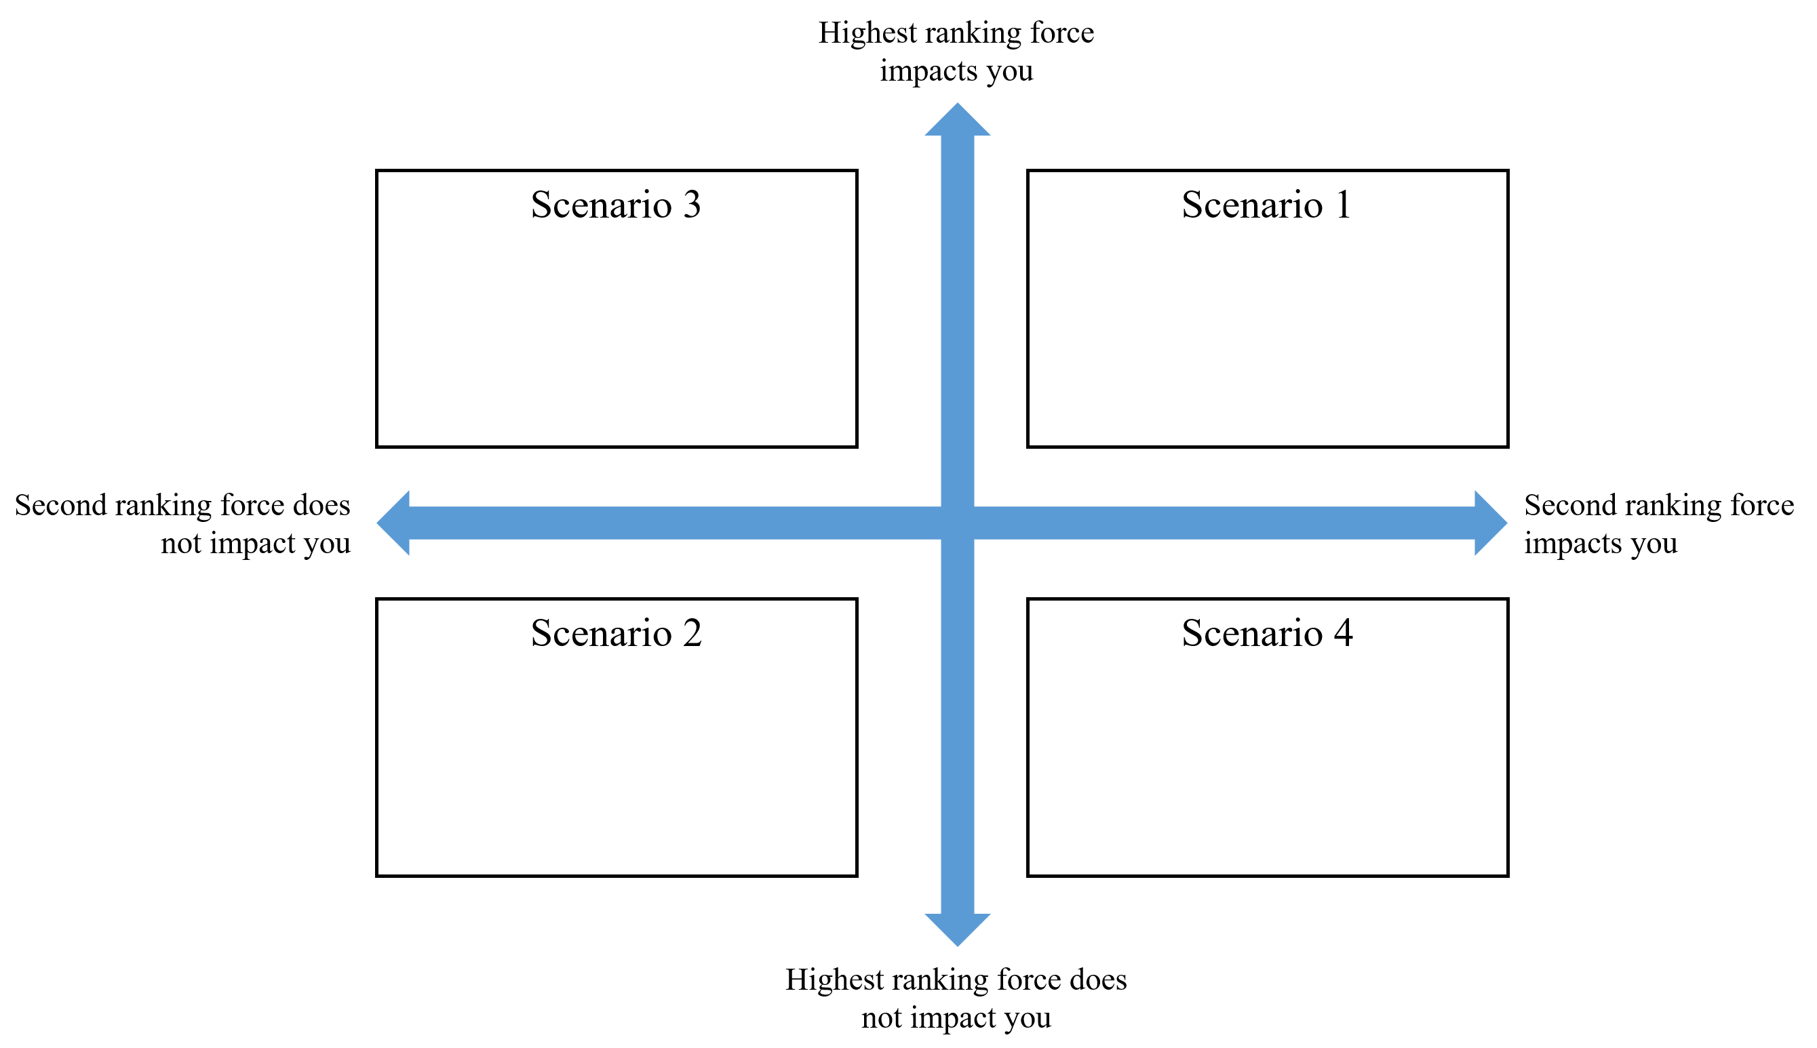 | Scenario 1:
 | Scenario 2:
 | Scenario 3:
 | Scenario 4:

Identify Warning Signals
Identify the warning signals you might need to track to determine which scenario is unfolding.

Strategize
Develop a broad strategy (i.e. multiple initiatives) to prepare for whatever scenario may unfold (especially your worst case scenario).

Assess
Assess what you learned from the project, and what was most challenging about it. For the purposes of this exercise, make some notes about the following:
- What was the most important thing you learned from this mini scenario planning exercise?
- What was the most challenging part of the exercise?

